## Merchant Name: Captivated Works Implementation POC: Michael *(IM to fill)* CX POC: *[IMP to Add]*

### 

### 

| Notes Sections   *(AE to fill if they have, Implementation to be completion DRI on handoff)*   * Info on how merchant bills   An annual flat fee and usage billed monthly  1) What is the merchant temperament?  Bryan (CEO) is super friendly, talked about basketball and his family more than anything else. Will likely be working with his daughter as well as she is the one that heads up billing  3) What are the Tabs features that the key POC cares about?  Ability to bill flexibly, didn’t like Maxio, felt too rigid |
| --- |

### Billing model *(Entire Section: Implementation to fill section)*

* Are there unique things about the customer creation process for this merchant?
* Information on how merchant bills
* How contract is broken up
* One off things to know about the merchant

### Contract Processing Steps *(Entire Section: Implementation/Success to fill Post-Go Live)*

1. **General**
   1. In the description of line items, there will be usage BTs and tier unit BTs that will need to be created
      1. [Example #1](https://garage.tabsplatform.com/prod/contracts/0ffdaf48-203d-4549-93fc-bc1bf87343ec/preview)
2. **Item Name:** use the line item name
3. **Item Description:** none
4. **Quantity:** Use the "QTY" field from the contract table; default to 1 if not listed
5. **Total Price:** Use the subtotal listed for each line item
6. **Service Start Date:** contract signature or start date
7. **Billing Start Date:** same as service start date
8. **Months of Service**
   1. If no total length available, default to 12 months
   2. If a length is stated like the below, use that

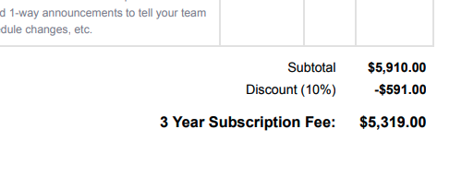

* 1. Month-to-month contracts should assume 12 months

1. **Frequency**
   1. Use the length to to infer. For example
      1. Monthly for all usage BTs (monthly price is typically listed)
      2. 1 year for annual of month
      3. 3 years for a 3 year subscription (if it is charged upfront like the above screenshot)
2. **Net Terms:** default to net 30 if not listed
3. **Usage BTs + Tier Unit BTs (**[Example #2](https://garage.tabsplatform.com/prod/contracts/4f2962d9-792e-48ef-94e9-06e5f3026763/terms/revenue)**)**

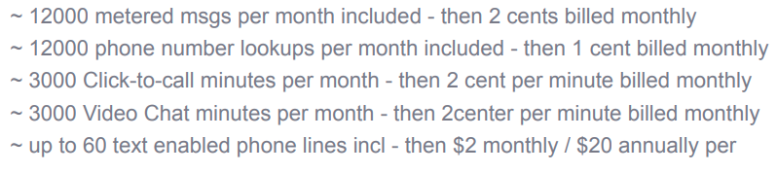

* 1. All of the above BTs in the description under “Annual Pro Plan” need to be added as usage BTs
     1. For the events that have an included amount, create a tier unit BT
        1. Use the quantity included
        2. Anything over will be charged at the rate

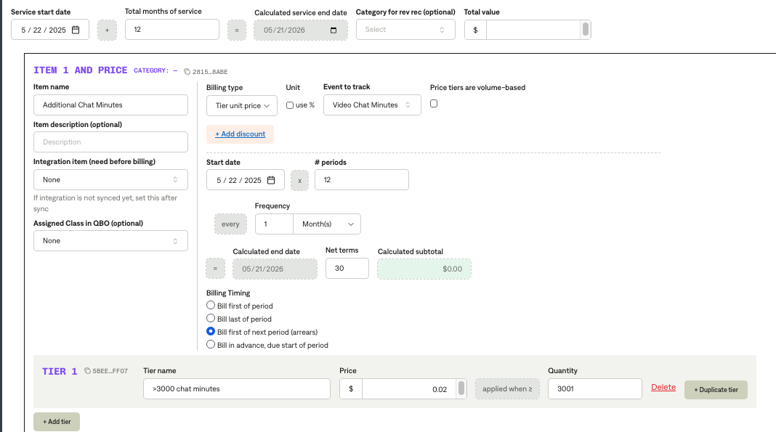

1. Ignore
   1. Late fees

1. Anything to ignore in contracts?
2. Specifics processing things the merchant has requested that may differ by contract (e.g. always back-date invoice date to final day of the month)
3. Default Service Term
   1. If None Listed, Ops Default is 1 Year
4. Default Net Payment Terms
   1. If None, Ops Default is 0
5. Default Billing Frequency
   1. If None Listed, Ops Default is Monthly
6. How do we handle taxes as a line item?
   1. If None Listed, Ops Default is every tax line item becomes a BT

### Events Processing (if necessary) *(Entire Section: Implementation/Success to fill Post-Go Live)*

* Any important information on events billing

Integration Items Processing (if necessary)  
*(Entire Section: Implementation/Success to fill Post-Go Live)*

* What are the instructions for assigning integration items?
* Example: All Statsig integrations items should be labeled as “Sales”
* Example: All “Pinata” integration items should be labeled as “Software Subscription Bundle” unless otherwise noted by Merchant

Post Processing Communications (if necessary)  
*(Entire Section: Implementation/Success to fill Post-Go Live)*

* Does the Ops Team need to notify anyone on the team re: completion of processing batches in Implementation or Active phase?
* Who needs to be notified and when?
  + Example:
    - Who: Customer Success [Azmat Aziz] needs to be notified
    - Where: Messari internal merchant channel
    - When: contracts are processed [Merchant Phase: Active]

### Customer Information *(Entire Section: Implementation/Success to fill Post-Go Live)*

* Any important information on specifics customers of this merchant
  + Special memo’s certain invoices require
  + Invoice changes due to merchant/customer relationship

### Feature Requests *(AE to fill for all requests prior to Imp handoff, Imp to fill prior to go-live/Success to fill to fill Post-Go Live)*

* FR 1
  + What is it
  + Why it's important
  + Urgency

### Merchant Calls *(AE to fill for all videos prior to Imp involvement, Imp to fill prior to go-live/Success to fill to fill Post-Go Live)*

* .
* .
* .